**Name – Ashish Mukherjee**

**Class – LY NS**

**Roll no. -2193060.**

**Batch – A.**

**ASSIGNMENT – 5**

**AIM** –Configure default SNMPv1, SNMPv2, SNMPv3 and enlist all environment parameters.

**THEORY -**

**SNMP BASICS**

SNMP GET request information from devices.  
SNMP SET makes changes to the devices.  
SNMP TRAP / INFROM Send urgent information to the Network Management System.

TRAP is unacknowledged packet.

INFROM is acknowledged packet.

**Versions**

SNMPv1 – original version, uses community strings, 2 types of communities RO and RW.

Community string needs to be agreed upon between the manager and agent ,sent in clear text.

SNMPv2 (SNMPv2c)-improved confidentiality and communication , added GetBulk and Inform

Original version 2 security was complex , 2c goes back to the original communities.

SNMPv3 – main improvement is in added security

Configuration -

* Add a new network to the router
* Add a switch
* Add PCs
* Connect PCs to switch with fastethernet cable
* Connect router with switch with gigabitethernet cable
* Assign the IP address to the ports of the router
* Set no shutdown

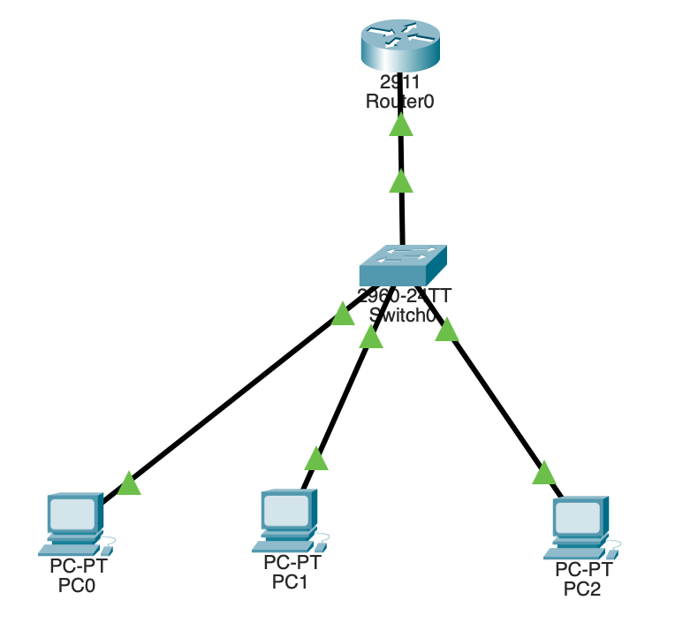  
 SNMP v3 Network

**Router CLI commands:**

Router>enable

Router#

Router#configure terminal

Enter configuration commands, one per line. End with CNTL/Z.

Router(config)#interface GigabitEthernet0/0

Router(config-if)#

Router(config-if)#exit

Router(config)#interface GigabitEthernet0/1

Router(config-if)#

Router(config-if)#exit

Router(config)#interface GigabitEthernet0/0

Router(config-if)#

Router(config-if)#exit

Router(config)#interface GigabitEthernet0/0

Router(config-if)#ip address 192.168.2.1 255.255.255.0

Router(config-if)#ip address 192.168.2.1 255.255.255.0

Router(config-if)#no shutdown

Router(config-if)#

%LINK-5-CHANGED: Interface GigabitEthernet0/0, changed state to up

%LINEPROTO-5-UPDOWN: Line protocol on Interface GigabitEthernet0/0, changed state to up

Router(config-if)#exit

Router(config)#

Router(config)#snmp-server community Router ro

%SNMP-5-WARMSTART: SNMP agent on host Router is undergoing a warm start

Router(config)#snmp-server community Router rw

Router(config)#

Router(config)#exit

Router#

%SYS-5-CONFIG_I: Configured from console by console

Router con0 is now available

Press RETURN to get started.

R1>

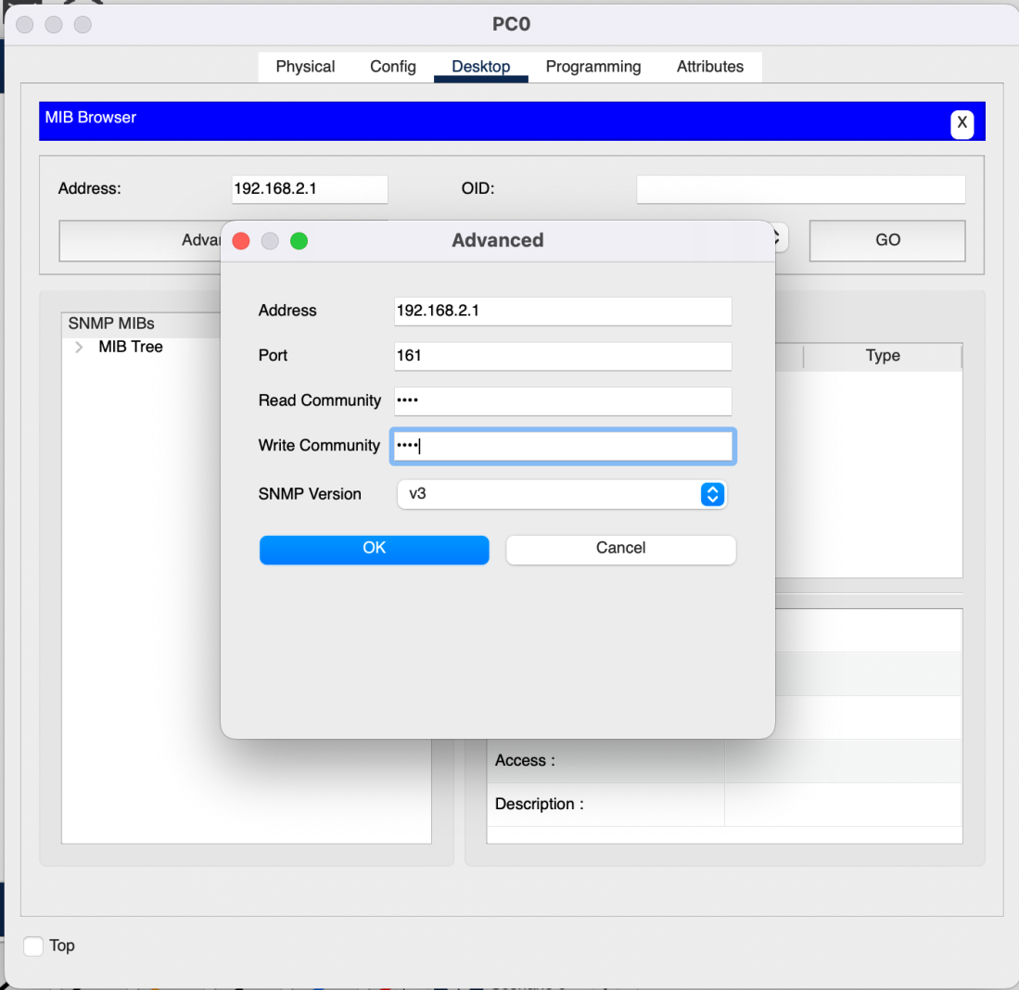

SNMP v3 Configuration

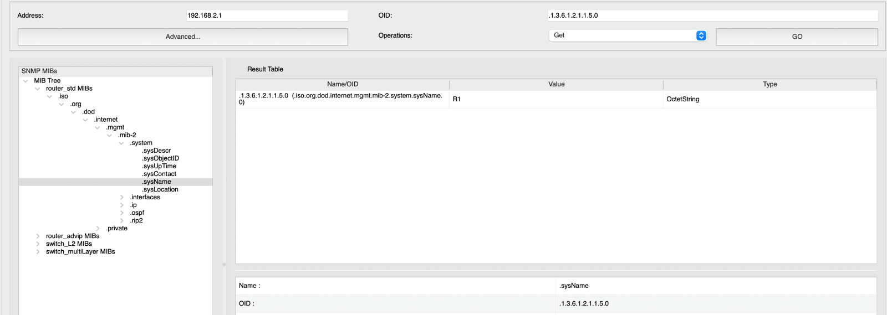 GET COMMAND

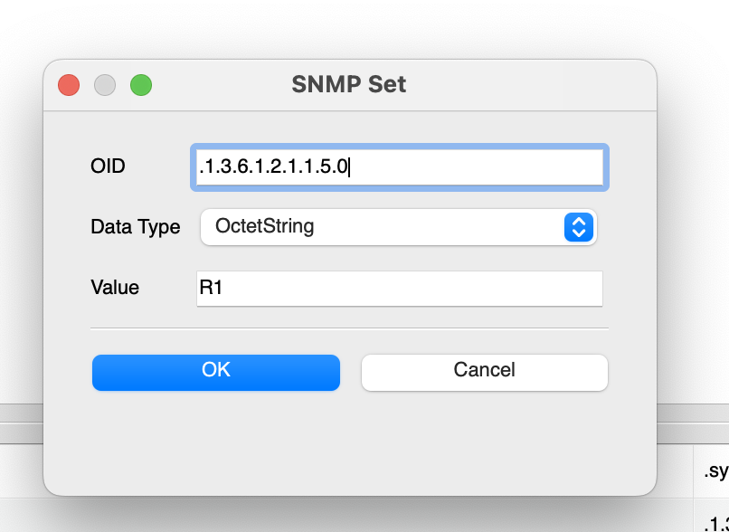 SET COMMAND

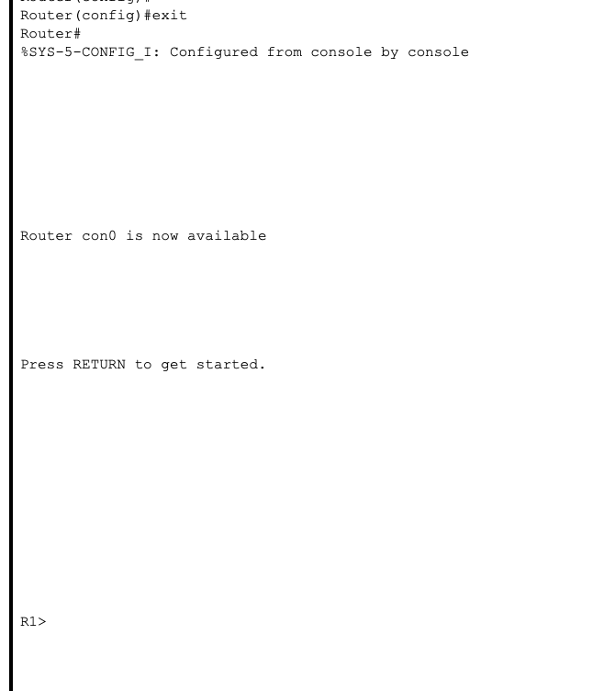  
 SET COMMAND RESULT

**Conclusion:**

We created and configured SNMP v3 architecture and using v3 PDUs GET and SET, we showed the working of the network.